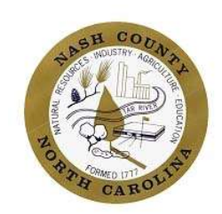
Nash County Board of Commissioners Recessed Meeting
March 24, 2026, at 6:00 p.m.
Nashville Exchange
Legislative Dinner Agenda

- Call to Order
Chairman Marvin C. Arrington

- Welcome
Chairman Marvin C. Arrington

- Invocation
Commissioner Gwen Wilkins

- Dinner

- Remarks from Legislators
Senator Lisa Barnes
Representative Allen Chesser
Representative Dante Pittman

- Remarks from Nash Community College
Dr. Lew Hunnicutt, President
- Presentation of Legislative Goals
Nash County Commissioners

- Legislative Goal Discussion

- Adjourn the Meeting

